<http://thecastlereagh.blogspot.com.au/2012/09/the-salt-caves-fire-tower.html>

[**The Salt Caves Fire Tower**](http://thecastlereagh.blogspot.com/2012/09/the-salt-caves-fire-tower.html)

Experiences of bushfires in the Pilliga Forest led to the consideration of a network of lookout towers placed to monitor the forest and detect fires. A huge fire burnt through the western Pilliga in November 1922 and newspaper reports of the time suggest that the full extent of this fire was unknown. As the drought of the 1930s developed great concern was expressed about the security of the forest. During the summer of 1932-1933 it was announced that the forests around Baradine would be patrolled by guards to protect against fire. Huge fires occurred in November 1935 and at this time it appeared that no system of monitoring the forests for fire was in place. Monitoring of fires from the rocky outcrop at the Salt Caves appears to have commenced some time around 1938. According to Eric Rolls lookout keeper Pommie Timms used a range finder set on a sawn-off Black Pine stump to identify the direction and distance of fires. According to old hand Doug Simpson, Forrester Ben Harris hired his father Steve Simpson to clear around and on top of the rocky outcrop at the Salt Caves. This was preparatory to the erection of the first fire tower on the site. Steve camped at the Salt Caves with his wife and three children while this work was being undertaken.

[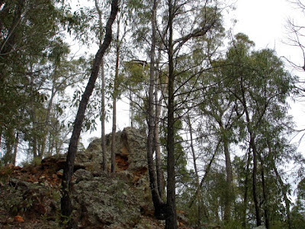](http://2.bp.blogspot.com/-PRyfUasz5dQ/UFj0EeESSGI/AAAAAAAABjU/0iSBIBK4UA0/s1600/DSC09154.JPG)

[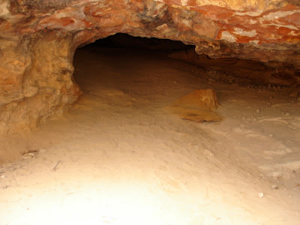](http://4.bp.blogspot.com/-g8tULiIuso8/UFj0E4RSAxI/AAAAAAAABjg/at8uHufotcE/s1600/DSC09171.JPG)

In late February 1939 Ben Harris decided to excavate a well at the east end of the outcrop to provide water for a fire-watcher. Steve Simpson and two other men were hired. One man was thin and the other short and stocky; so both men could work down the well together for the purpose of blowing through granite if they encountered any, which they did, about every ten feet. At a depth of about eight metres the well sinkers struck foul air. Candles were used to test the air in the hole. They averaged about three metres per week until they eventually reached a depth of lmost forty six metres. The crew intersected a number of small water seepages as they dug but never reached a sustainable supply of water. According to Noel Warland the well was filled-in some time after 1984

[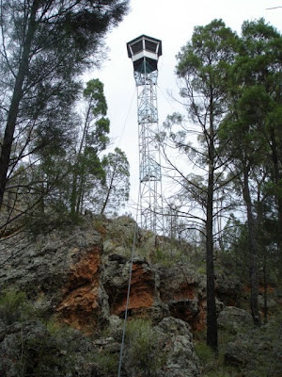](http://4.bp.blogspot.com/-4EbBQbU4I2I/UFj0uiJnsqI/AAAAAAAABjs/Vx9KDuKWG54/s1600/DSC09163.JPG)

[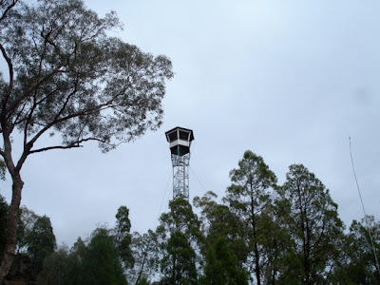](http://1.bp.blogspot.com/-srxc6PJlvUc/UFj0vBoK-BI/AAAAAAAABj4/VBibsxTlq2Y/s1600/DSC09174.JPG)

By the end of 1939 a network of fire towers had been erected in the forest. According to Eric Rolls a high tower was built in the yard of the Forestry Office in Baradine in 1937 . In January 1939 it was announced that the forest would be patrolled by cars fitted with radios that would act as “wireless fire alarms”. In December 1939 it was announced that a network of radio-equipped fire towers had been erected in the Pilliga State Forests. These towers were capable of communicating with the forest headquarters in Baradine. The main tower was located at Yarrigan, the highest point in the forest and a second tower was constructed at the Salt Caves. The Salt Caves fire tower was erected in the Denbollie State Forest that had been dedicated in July 1935. Small residences were constructed near each of the fire towers and lookout keepers stationed at each during the summer months. Noel Warland, District Forester from 1951 to 1976, believes that the original forest headquarters building was transferred to the Salt Caves in 1939 following the construction of the new Baradine Forestry Office. This building became the lookout keeper’s residence at the Salt Caves. A new timber radio antenna was erected on the outcrop in 1954. This was later replaced by a removable antenna supported by steel angle posts. The original lookout tower was demolished in 1971 and a new steel tower erected. The 1971 tower was demolished in 2012 to make way for a tower more suitable for public access.

[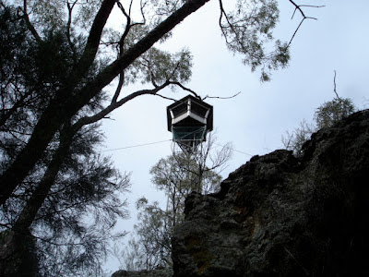](http://2.bp.blogspot.com/-QFHE8Z1RwGQ/UFj0279wMsI/AAAAAAAABkE/80ZhfblZWY8/s1600/DSC09173.JPG)

Posted 19th September 2012 by [Jose the travelling padre](http://www.blogger.com/profile/17328003063287040954)